Section 2: Project Update Summary
Danala Group 7 | PRT661 – Data Science Practice | Semester 2, 2026
Since Assessment 1, the project has progressed from a proposed binary CNN to an implemented comparison of logistic regression, PotatoCNN and MobileNetV2. The workflow now includes leaf-group-aware splitting, validation-selected thresholds, internal and external evaluation, and reliability analysis.
Changes since Assessment 1
Area | Previous state | Current state | Justification
Data and split | PlantVillage; grouped splitting preferred | 2,000 images; 500 leaf groups; zero shared groups | Reduce leakage between related leaf images.
Models | Lightweight CNN proposed | Logistic regression, PotatoCNN and MobileNetV2 | Compare traditional, custom and transfer-learning models.
Evaluation | Core metrics and visualisations planned | Locked internal test, PlantDoc evaluation and diagnostics | Assess generalization and reliability.
Delivery | Proposal and planned repository | Executed notebook, saved models, reports and repository evidence | Provide traceable implementation and results.

Contribution summary
Team member / student ID | Documented contribution area
Kavya Sree Sunkara / S386025 | Data acquisition and repository setup
Sayed Mahidul Islam Rafel / S387949 | Image preprocessing and exploratory analysis
Mahdi Hasan Abdullah / S394885 | Model development and training
Partha Mallik / S392819 | Evaluation, visualisation, error analysis and evidence uploads
Datta Sai Kanaparthi / S385673 | Documentation, ethics review and final integration

Evidence locations
Evidence | Location / supporting record
Implementation | notebooks/CODE.ipynb in the accompanying repository package
Results and figures | artifacts/tables/; artifacts/figures/
Architecture and planning | architecture/; planning/
Project governance | project_management/; commit history

GitHub repository: Danala Group 7
MobileNetV2 achieved 99.67% accuracy on the internal test and 58.56% on PlantDoc. The external performance gap supports retaining the research proof-of-concept scope and prioritising representative field data and further validation.

Section 3: Assessment 2 Technical Development
3.1 Continuity with Assessment 1 and evidence basis
The original research question asks whether a CNN can distinguish Early Blight from Late Blight using visible potato-leaf characteristics. The implemented work retains the same two-class objective and adds stronger controls, comparators and external evaluation. The current milestone demonstrates a working analytical pipeline and exposes limitations that must guide the next stage.
Section 1 now preserves the complete four-page Dan Group 7 Theme 2 PP.pdf supplied in this update. Its cover identifies Danala Group 7, all five students, Semester 2 of 2026, a submission date of 11 August 2026 and the GitHub repository. This team-specific proposal replaces the earlier placeholder copy. Its existing wording and original figure remain unchanged.

What has changed since the proposal
The proposal already preferred leaf-group-aware splitting when possible. The implementation makes it mandatory and validates zero shared groups. The proposal’s CNN concept is now accompanied by a traditional logistic model and trained MobileNetV2 comparator. Validation controls checkpoints and operating thresholds; a separate PlantDoc corpus tests source-domain transfer. Calibration, segmentation, perturbation, ablation and explainability outputs broaden the evidence.
The original proposal incorrectly describes a false negative as a diseased leaf predicted healthy. There is no healthy class in this task. Throughout this continuation, Late Blight is label 1 and Early Blight is label 0: a false negative is Late Blight predicted Early Blight. This correction is documented here while preserving the supplied Assessment 1 pages.

Review method and source precedence
This report is based on inspection of the executed notebook, exported CSVs, packaged model files, planning records and existing reports. No model was retrained for this progress review. Saved outputs establish evidence of a previous run; independent rerun reproducibility remains to be demonstrated. Where narrative or slides conflict with current numerical outputs, this report uses the notebook and matching CSVs.
Source | Use in this progress report
Assessment brief, pages 1–5 | Section order, searchable PDF, page/font limits and individual requirements.
Dan Group 7 Theme 2 PP.pdf | Team-specific Assessment 1 baseline, identities, IDs, date and repository URL.
Notebook and artifacts/tables/ | Implemented method and numerical evidence.
Planning records and ZIP inventory | Status, governance gaps and deliverable availability.

Primary implementation:
notebooks/Potato_Blight_Final_Feedback_Incorporated_Colab.ipynb. This report references notebook cell headings rather than unstable execution counters.
New source records: Dan Group 7 Theme 2 PP.pdf; team_structure_responsibilities.pdf; CODE.ipynb.
3.2 Updated system architecture
From a single-model proposal to a controlled comparison pipeline
The implementation separates data preparation, fitting, validation decisions and final evaluation. CSV outputs preserve the connection between labels, split membership, predictions and reported metrics. Raw source revisions are pinned, and derived transformations are kept distinct from the original images.
Stage | Implemented component and output
1. Acquire | Pinned PlantVillage and PlantDoc sources; inventory and provenance.
2. Audit and partition | Official leaf-group identifiers; 350/75/75 train/validation/test groups; overlap audits.
3. Prepare | 224 × 224 RGB and ImageNet normalisation for neural models; 32 × 32 grayscale for logistic regression; augmentation only in training.
4. Fit | Logistic pipeline, compact PotatoCNN and ImageNet-pretrained MobileNetV2.
5. Validate | Best checkpoint and model-specific F1 threshold selected on validation data.
6. Evaluate | Frozen internal test; unchanged models and thresholds on external PlantDoc.
7. Diagnose | Errors, Grad-CAM, features, calibration, ablations, segmentation and perturbations.
8. Package and present | CSV/PNG evidence, saved models, environment record and optional Gradio probability display.

Component boundaries
The loader supplies images and labels; training updates parameters; validation selects checkpoints and operating policies; evaluation exports predictions and metrics. PlantDoc labels are reserved for evaluation. The model and its preprocessing and threshold must be treated as one versioned configuration, because changing representation changes the probability scale.

Design choices and tradeoffs
Python, PyTorch and Torchvision support the implemented neural workflow, while scikit-learn provides the traditional baseline and metric routines. A file-based design suits the 2,000-image experimental corpus and supports direct inspection. A database, streaming pipeline and production hosting are not demonstrated by the supplied work. The architecture documents describe deployment possibilities, but these remain design extensions.
Design evidence: architecture/02_final_high_level_system_architecture.png; architecture/03_final_workflow_diagram.png; architecture/ARCHITECTURE_AND_DESIGN.md; artifacts/documentation/SYSTEM_ARCHITECTURE.txt. The table above is a readable rendering of the implemented flow.
3.2a Architecture figure
Implemented separation of data, fitting, validation and evaluation
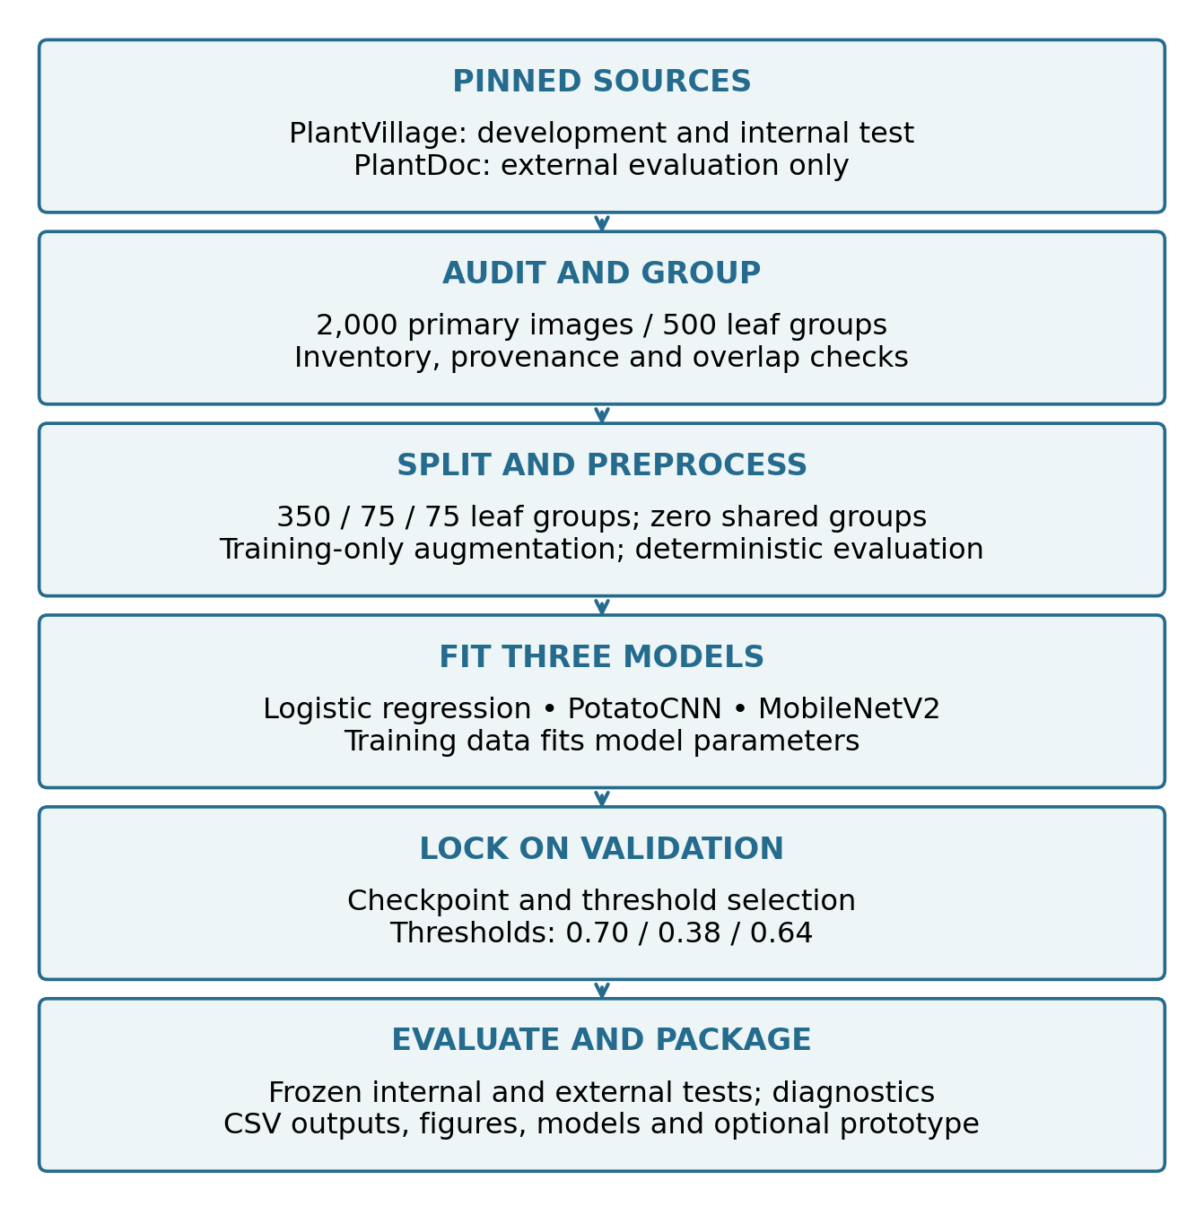

Figure 2: Updated architecture, redrawn from the supplied implemented-system specification. PlantDoc remains external to fitting and threshold selection.
Source architecture specification
The validation gate is the key control: each model is frozen before the internal and external evaluations. Augmentation operates only on the training partition; diagnostics do not retrospectively redefine the headline result.
3.3 Data acquisition, provenance and storage
Pinned sources and traceable experimental inputs
The recorded PlantVillage potato subset contains 2,000 JPEG images at 256 × 256 pixels, with 1,000 images per disease class and an aggregate size of approximately 34.71 MiB. The notebook resolves 500 underlying leaf groups with four captures per group. This distinction matters: 2,000 image files do not represent 2,000 independent specimens.
Source | Recorded revision / use
PlantVillage | Training, validation and internal testing.
PlantDoc | 222 external images: 117 Early Blight and 105 Late Blight; no fitting or tuning.

Storage organisation
The notebook uses a Colab working directory under /content/PlantVillage-Dataset/raw and produces tables, figures, models and documentation. The supplied Windows repository contains the notebook, assessment reports, architecture and planning material, and exported tables/figures. Absolute Colab paths in CSVs describe the original runtime and will need reconstruction or mapping when reproducing the work elsewhere.
Three trained model files are present inside Potato_Blight_Final_Report_Ready.zip: models/baseline_logistic.joblib, models/best_potato_cnn.pt and models/best_mobilenet_v2.pt. They are not present under the extracted repository’s artifacts/models/ location, although the task register points there. Model creation is evidenced by the archive, but repository packaging is incomplete.

Five-V profile
Dimension | Project-specific interpretation
Volume | Small, auditable image corpus; 2,000 primary images / 500 leaf groups.
Velocity | Static revision-pinned sources; no live ingestion demonstrated.
Variety | RGB captures, segmented representations and a different external image source.
Veracity | Public labels, group identifiers and hash audits; no claim of expert relabelling.
Value | Reproducible comparison and a preliminary two-disease classification prototype.

The supplied provenance note flags that PlantVillage redistribution terms require confirmation and records PlantDoc as CC BY 4.0. These are the project’s recorded licensing observations, not a fresh legal verification. Retain source attribution and resolve redistribution permissions before including raw images in a public release.
artifacts/tables/five_vs_summary.csv; artifacts/documentation/DATA_PROVENANCE_AND_LICENSES.txt; Potato_Blight_Final_Report_Ready.zip (workspace root).
3.4 Data engineering, cleaning and leakage control
Partition by underlying leaf before any augmentation
The notebook inventories file properties and class labels, resolves official leaf identifiers and checks the expected group structure. Each leaf group is assigned wholly to one partition. Class-wise group allocation gives a balanced training set and slightly different validation/test class totals because groups, rather than individual images, are allocated.
Partition | Early | Late | Images | Leaf groups
Training | 700 | 700 | 1,400 | 350
Validation | 148 | 152 | 300 | 75
Test | 152 | 148 | 300 | 75
Total | 1,000 | 1,000 | 2,000 | 500

Recorded leakage checks
Comparison | Shared groups | Exact matches | Near matches
Train–validation | 0 | 0 | 0
Train–test | 0 | 0 | 0
Validation–test | 0 | 0 | 0

The image audit checks MD5 equality and perceptual dHash similarity at Hamming distance ≤ 4. The PlantDoc overlap export records zero exact matches and zero external images with a near-match to the primary corpus at that threshold. These controls address the measured overlap routes; they do not prove that public labels are correct or that no other dependence exists.

Preprocessing contract
Neural inputs are converted to RGB, resized to 224 × 224 and normalised with ImageNet statistics. Training adds horizontal flipping, rotation up to 15 degrees and random resized crop with scale 0.9–1.0. Validation and test preprocessing is deterministic. Logistic regression uses 32 × 32 grayscale pixels with a scaler fitted within the training pipeline.
The balanced 700/700 training labels justify disabling class weighting. No oversampling or synthetic image creation is needed to correct class imbalance in this run. Segmented images are handled as a separate sensitivity experiment and must not be mixed into the primary colour evaluation without an explicitly validated policy.
artifacts/tables/split_summary.csv; train_split.csv; validation_split.csv; test_split.csv; leaf_group_overlap_audit.csv; duplicate_audit.csv; plantdoc_external_overlap_audit.csv. Notebook headings: official leaf-group-aware split; dataloaders; cross-split duplicate audit.
3.5 Analytics and model implementation
Three completed modelling approaches
Model | Implementation | Purpose
Logistic regression | 32 × 32 grayscale; StandardScaler; liblinear solver; maximum 1,500 iterations; seed 42. | Traditional reference for the neural models.
PotatoCNN | Three 3 × 3 convolution blocks with 32/64/128 channels, ReLU and max pooling; dropout 0.30; one output logit; 93,377 parameters. | Compact task-specific model.
MobileNetV2 | ImageNet-pretrained weights; binary head; head-training phase followed by partial feature fine-tuning. | Transfer-learning comparator.

Custom CNN optimisation
PotatoCNN uses BCEWithLogitsLoss and Adam at a learning rate of 0.001, with batch size 32 and a maximum of 20 epochs. Early stopping monitors validation loss with a patience of five epochs and restores the best weights. Sigmoid converts the output logit to a Late-Blight score for evaluation. Balanced training labels leave the positive-class loss weight disabled.

Transfer-learning optimisation
The MobileNetV2 classifier is replaced with a single-output linear head. Feature parameters are initially frozen; the head phase permits up to four epochs at a learning rate of 0.001. The final two feature blocks are then made trainable for up to four epochs at 0.0001. The best validation-loss checkpoint is restored before threshold selection. The saved history supplies evidence of the executed stages.

Decision policy
Model | Validation-selected threshold
Logistic regression | 0.70
PotatoCNN | 0.38
MobileNetV2 | 0.64

The shared threshold-selection function optimises validation F1. A Late-Blight prediction occurs when its score meets the model’s threshold. These are model-specific operating policies, not interchangeable probability cutoffs. The external evaluation applies the same frozen thresholds without using PlantDoc labels for selection.
artifacts/tables/custom_cnn_configuration.csv; training_history.csv; mobilenet_v2_training_history.csv; final_model_comparison.csv. Models are in the report-ready ZIP. Notebook headings: Traditional baseline; Lightweight CNN; MobileNetV2 transfer-learning comparator.
3.5a Data split and training figures
Balanced classes, independent leaf groups and recorded optimisation
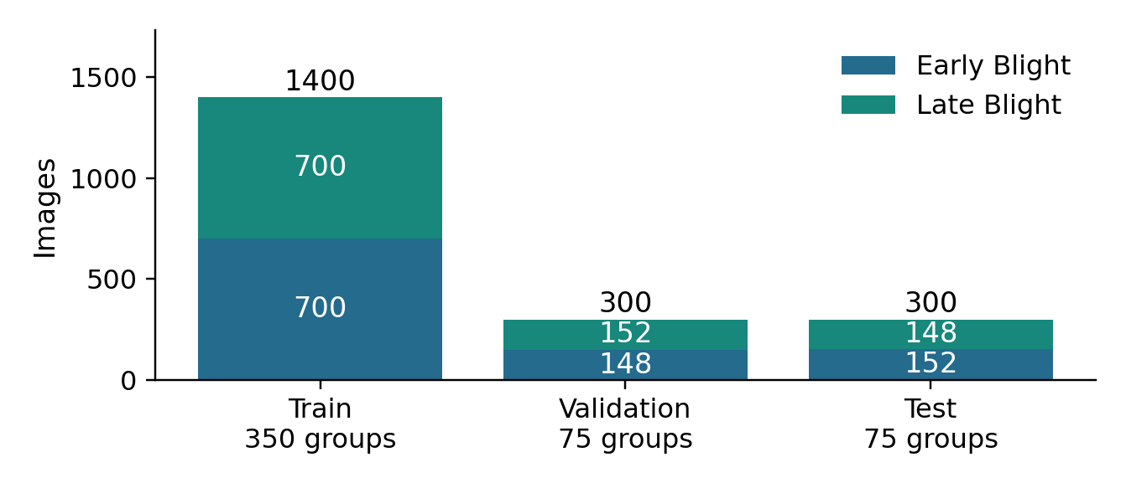
Figure 3. Image counts by class and split, with the number of underlying leaf groups below each partition. Source: split_summary.csv.
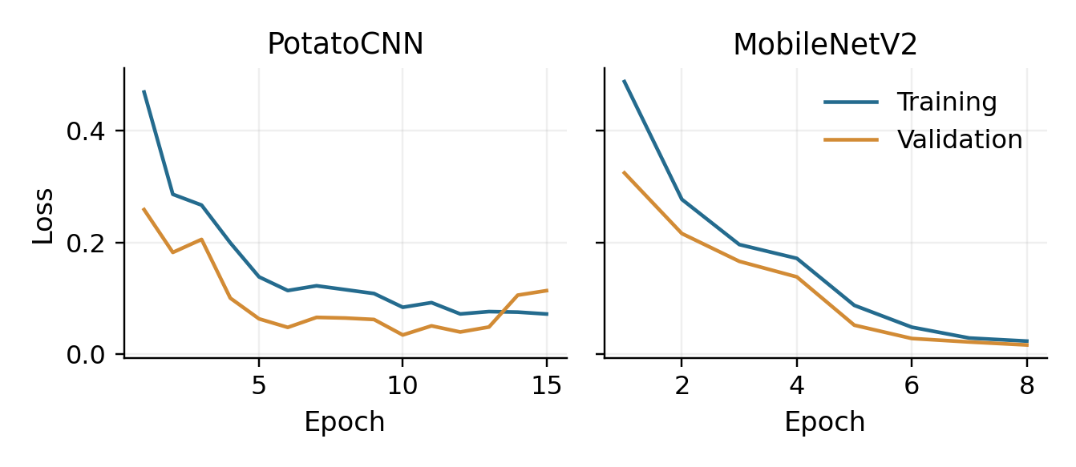
Figure 4. Recorded training and validation losses for PotatoCNN and MobileNetV2. These show saved optimisation histories, not an independent rerun.
Split evidence
PotatoCNN training history
MobileNetV2 training history
3.6 Locked internal evaluation
300 test images from 75 previously unseen leaf groups
All models are evaluated on the same internal test partition, comprising 152 Early-Blight and 148 Late-Blight images. Late Blight is the positive class. Accuracy measures overall correctness; precision and recall describe Late-Blight predictions; F1 balances their tradeoff; ROC-AUC measures score ranking across thresholds.
Model | Accuracy | Precision | Recall | F1 | ROC-AUC
Logistic | 0.9100 | 0.8903 | 0.9324 | 0.9109 | 0.9624
PotatoCNN | 0.9533 | 0.9408 | 0.9662 | 0.9533 | 0.9952
MobileNetV2 | 0.9967 | 1.0000 | 0.9932 | 0.9966 | 1.0000

Model | TN | FP | FN | TP | Errors
Logistic | 135 | 17 | 10 | 138 | 27
PotatoCNN | 143 | 9 | 5 | 143 | 14
MobileNetV2 | 152 | 0 | 1 | 147 | 1

MobileNetV2 correctly classifies 299 of 300 internal images. The custom model improves accuracy by 4.33 percentage points over logistic regression; MobileNetV2 improves by another 4.33 points over the custom model. These are controlled-source results and should be interpreted together with the external test, not used as a stand-alone field-performance claim.

Paired comparison and statistical limits
Comparison | Exact McNemar p-value
Logistic vs PotatoCNN | 0.02412
Logistic vs MobileNetV2 | 0.0000002161
PotatoCNN vs MobileNetV2 | 0.0009766

The stored image-level McNemar tests report nominal p-values below 0.05 for all pairs. However, each test leaf contributes four related captures, so image-level independence is questionable. Multiple pairwise comparisons also warrant care. Treat these tests as exploratory support; leaf-group-aware uncertainty estimates and repeated-seed evaluation remain useful follow-up work.

Threshold correction
At threshold 0.50, PotatoCNN also has accuracy 0.9533, but Late recall is 0.9527. At 0.38, recall rises to 0.9662 and precision falls to 0.9408. Equal accuracy therefore does not mean identical predictions. The continuation corrects the older narrative implying that decisions were unchanged.
artifacts/tables/final_model_comparison.csv; model_mcnemar_tests.csv; validation_threshold_comparison.csv; misclassified_samples.csv. Counts and rates shown here are taken from the saved exports.
3.7 External evaluation and generalisation
Completed PlantDoc experiment reveals substantial domain shift
The supplied notebook and external CSVs demonstrate that PlantDoc evaluation has already been performed. This supersedes the earlier progress slides, which list external validation as future work. The external cohort contains 222 images with 117 Early-Blight and 105 Late-Blight labels; it was not used to fit parameters or select thresholds.
Model | Accuracy | Late recall | Late F1 | ROC-AUC
Logistic | 0.4865 | 0.5524 | 0.5043 | 0.5044
PotatoCNN | 0.5135 | 0.0762 | 0.1290 | 0.5361
MobileNetV2 | 0.5856 | 0.4095 | 0.4831 | 0.6210

Model | Internal accuracy | External accuracy | Drop, percentage points
Logistic | 91.00% | 48.65% | 42.35
PotatoCNN | 95.33% | 51.35% | 43.98
MobileNetV2 | 99.67% | 58.56% | 41.11

MobileNetV2 has the highest external accuracy and ROC-AUC among the three models, but logistic regression has the highest external Late-Blight F1. This illustrates why “best” depends on the metric. MobileNetV2 misses 62 of 105 Late-Blight images; PotatoCNN misses 97. Internal success does not transfer reliably to this source.

What the result establishes
The experiment provides direct evidence of cross-source performance degradation under the frozen evaluation policy. The zero-overlap audit reduces the risk that external scores are inflated by matched images. The result justifies retaining the proof-of-concept scope and prioritising representative data over further optimisation of the controlled benchmark.

What remains uncertain
PlantDoc is a small, public, internet-sourced dataset, not a prospective farm study with independently verified diagnoses. Differences may involve capture conditions, background, symptom presentation or label quality. The current evidence does not isolate their causal contributions. Future work should use specimen-grouped, expert-reviewed data across sites and devices, while retaining an untouched confirmation cohort.
artifacts/tables/plantdoc_external_metrics.csv; plantdoc_external_predictions.csv; plantdoc_external_overlap_audit.csv. Supporting figure: artifacts/figures/plantdoc_external_confusion_matrices.png.
3.7a Internal and external performance figures
The external source exposes limits concealed by high internal accuracy
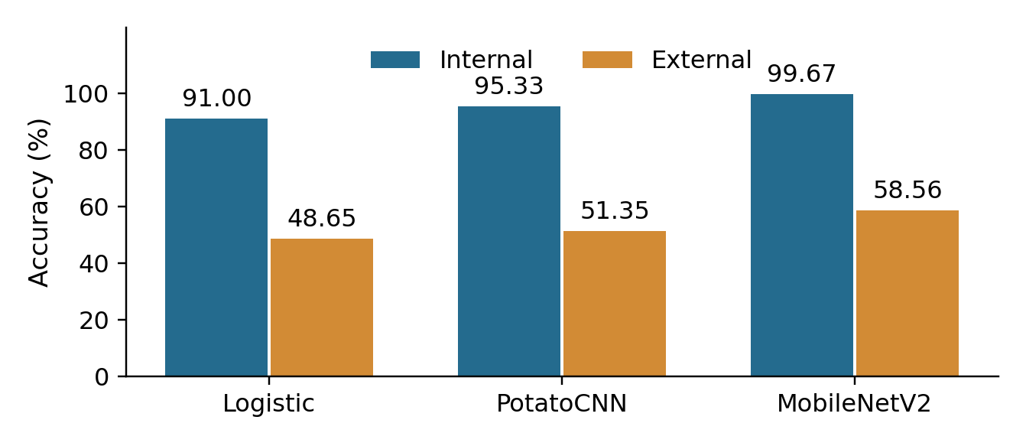
Figure 5. Accuracy on the 300-image internal test and 222-image external PlantDoc set. Values are percentages; frozen model-specific thresholds are retained.
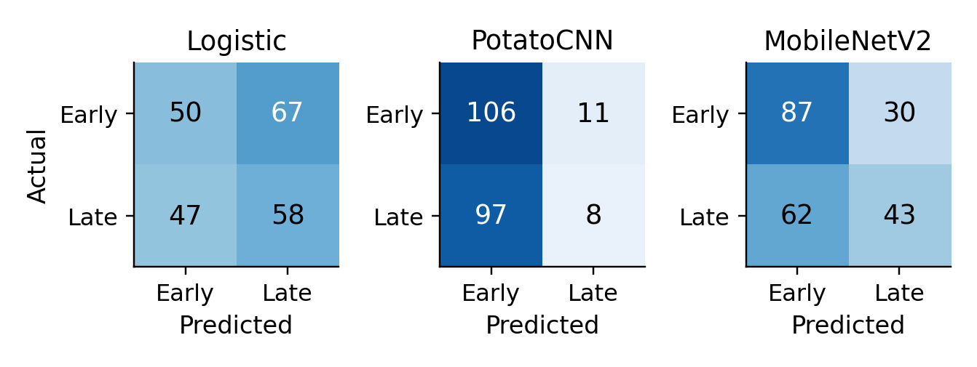
Figure 6. External PlantDoc confusion matrices. Rows are actual labels and columns are predicted labels. Late Blight is the positive class.
MobileNetV2 has the strongest external accuracy, but still misses 62 of 105 Late-Blight images. PotatoCNN misses 97. The external evaluation therefore changes the interpretation of the controlled-domain result.
Internal model comparison
External model metrics
3.8 Robustness, segmentation and ablation
Completed sensitivity experiments on the custom CNN
Condition | Accuracy | Late F1 | ROC-AUC
Original colour | 0.9533 | 0.9533 | 0.9952
Dark | 0.4933 | 0.6607 | 0.4951
Bright | 0.7000 | 0.5631 | 0.9761
Contrast | 0.8633 | 0.8783 | 0.9924
Blur | 0.8733 | 0.8862 | 0.9884
Rotation | 0.9500 | 0.9492 | 0.9947
Noise | 0.9500 | 0.9492 | 0.9934

Darkness causes the strongest loss of accuracy and ranking quality. Brightness preserves relatively high ROC-AUC while reducing F1, indicating that score ranking and a fixed operating threshold can behave differently. These perturbations provide controlled sensitivity evidence; they do not cover all real-world camera and lighting variation.

Segmented representation
Applying the colour model to segmented images at threshold 0.50 produces no positive predictions in the recorded experiment. Selecting a threshold on segmented validation images yields 0.01. Applied once to segmented test images, this gives accuracy 0.8800, F1 0.8784 and ROC-AUC 0.9566. The result shows substantial representation sensitivity. Threshold adjustment is not equivalent to establishing calibrated probabilities.

Validation-only regularisation ablation
Configuration | Validation accuracy | Validation F1
No augmentation; no dropout | 0.9967 | 0.9967
Augmentation; no dropout | 0.9933 | 0.9935
No augmentation; dropout | 0.9933 | 0.9935
Augmentation; dropout | 0.9933 | 0.9935

The ablation outcomes are validation results from separate training runs, not replacements for the frozen main test result. Small differences in this highly separable source do not establish that regularisation is unnecessary. There is no multi-seed confidence interval or external ablation comparison in the supplied exports.
artifacts/tables/robustness_results.csv; segmented_test_metrics.csv; segmented_calibrated_metrics.csv; ablation_results.csv. Notebook headings: segmented threshold calibration; validation-only ablation study.

3.9 Error analysis, explainability and probability quality
Diagnostics provide evidence for review, with explicit limits
The current custom-CNN error export contains 14 images: nine Early-Blight images predicted Late and five Late-Blight images predicted Early. The older final-report caption referring to “all five” errors is stale. The full 14-row CSV should be the authoritative error inventory, even where an image montage displays only a subset.

Interpretability outputs
The notebook generates predicted-class Grad-CAM overlays and PCA/t-SNE views of learned features. These help inspect model sensitivity, class separation and problematic examples. Heatmaps are not lesion annotations or causal explanations. Feature separation within the internal test set is not evidence of reliable separation on PlantDoc.
Diagnostic | Completed evidence | Interpretive limit
Error inventory | misclassified_samples.csv | An image-level record, not expert diagnosis.
Grad-CAM | gradcam_predicted_class.png | Sensitivity map; not proof of pathology.
Feature projection | feature_pca.png; feature_tsne.png | Exploratory embedding views, not statistical validation.
Reliability | calibration_curve.csv; reliability_diagram.png | Controlled-domain probability assessment.

Confidence and calibration
The stored confidence cell reports a mean confidence of 0.9652, a mean confidence of 0.9764 for correct predictions and 0.7371 for errors, with a Brier score of 0.0299. Confidence is computed from the larger of the two class scores. These summaries describe the recorded custom model on internal data. They do not validate confidence under domain shift.
The optional prototype flags a maximum class score below 0.75. This is an implemented heuristic, not an empirically validated rejection policy. A confidently wrong external prediction may pass it. Prospective work should evaluate calibration, referral frequency and error rates on accepted versus referred cases, using data representative of the intended setting.

Progress implication
The project now offers more than aggregate accuracy: reviewers can trace error direction, inspect example sensitivity and compare confidence with correctness. The next analytical improvement is to connect these diagnostics to a tested data-quality or abstention policy, rather than merely adding more visualisations.
artifacts/tables/misclassified_samples.csv; calibration_curve.csv; feature_embeddings.csv. Notebook headings: misclassified test images; predicted-class Grad-CAM; confidence + calibration + uncertainty visualisation.
3.9a Robustness and calibration figures
Sensitivity and confidence diagnostics for the custom CNN
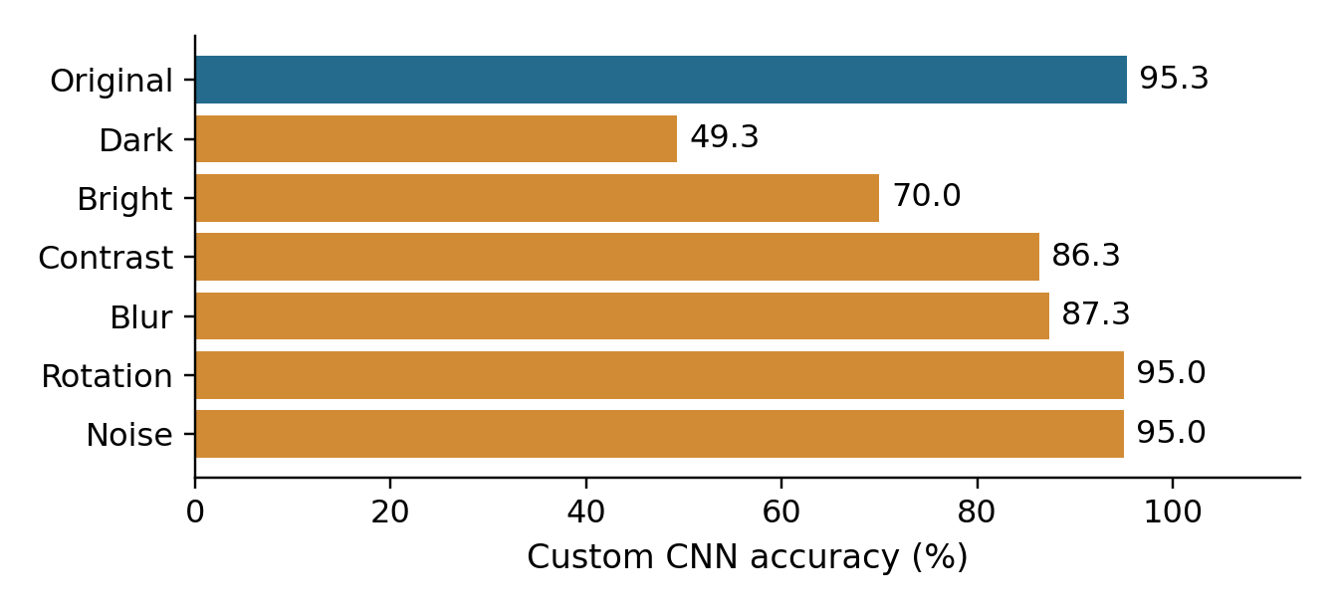
Figure 7. Custom-CNN accuracy under the recorded image perturbations. Darkness produces the largest deterioration. Source: robustness_results.csv.
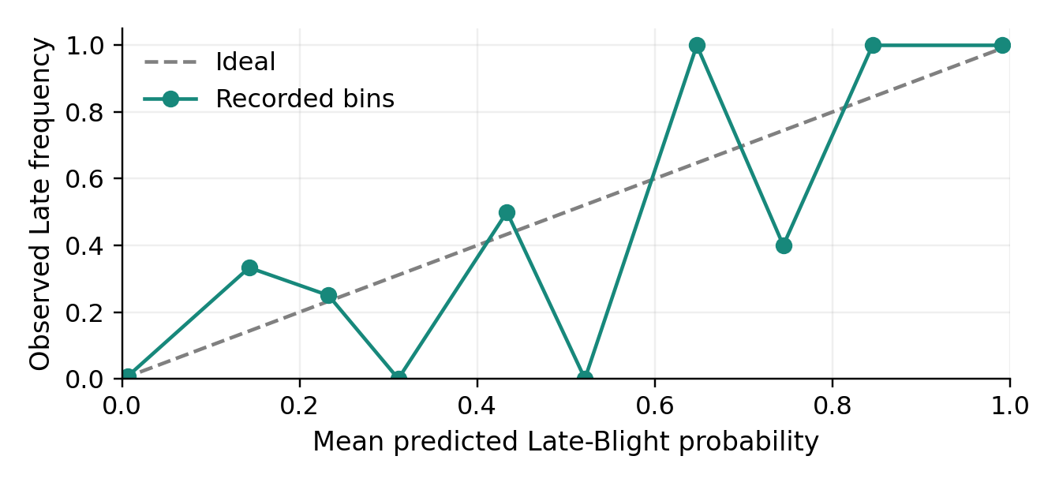
Figure 8. Internal-test reliability diagram from exported probability bins. Departures from the diagonal indicate disagreement between model scores and observed frequency.
The reliability curve is descriptive: bin sample counts are not shown and external-domain calibration is not established. Lighting sensitivity and PlantDoc results remain important limits on the model’s confidence.
Perturbation results
Calibration bins

3.10 Workflow, reproducibility and interface progress
Executed notebook available; independent reproduction and release integration remain open
The working sequence is acquisition → inventory/grouping → split → preprocessing → model fitting → validation locking → internal evaluation → external evaluation and diagnostics → packaging. The notebook contains executed outputs for the core analysis and exports evidence used in this report. This review checks consistency of saved evidence and does not claim a new training run.
Recorded runtime item | Value in ENVIRONMENT.txt
Python | 3.13.15
PyTorch / Torchvision | 2.11.0+cu128 / 0.26.0+cu128
Device / CUDA | CUDA device / 12.8
Seed | 42
Custom model profiling | 93,377 parameters; 0.3601 MB; 0.8186 ms/image; 1,221.6 images/second

Timing is specific to the recorded runtime and is not a mobile-device latency guarantee. A core environment record exists, but a clean-environment rerun has not been demonstrated. The public repository has a short root README; the inspected public tree contains no notebook, model files or requirements file. The local notebook and archived models are available separately. Expand setup and execution instructions and publish the missing technical files.

Reproduction acceptance procedure — proposed next work
Step | Acceptance evidence
1. Assemble the release | Publish the local notebook and three archived models; expand the public README and add dependency/setup instructions.
2. Recreate the data | Retrieve the recorded revisions, resolve paths and confirm the 2,000-image / 500-group inventory.
3. Run and compare | Execute in a clean environment; compare split hashes, audit counts and exported metrics with the saved reference.
4. Record the result | Save environment, versions, execution log, discrepancies and reviewer sign-off.

Prototype status
The notebook implements a Gradio inference function returning Early/Late scores and a scope warning, with a low-confidence flag. LAUNCH_DEMO is False in the supplied code. The code is evidence of a prototype; it is not evidence of an active deployed service or completed usability testing. A demonstration should verify model loading and output behaviour before claiming live operation.
artifacts/documentation/ENVIRONMENT.txt; artifacts/tables/model_efficiency.csv; notebook headings: responsible prediction-interface prototype; corrected report-ready package. Archived models: Potato_Blight_Final_Report_Ready.zip/models/.
Verified repository tree
3.11 Project governance and change management
Technical task records exist; collaboration claims need authentic activity evidence
The local task register lists POT-01 through POT-15 as Done and POT-16 as Needs team input. The new responsibilities record links these allocations to Kavya Sree Sunkara, Sayed Mahidul Islam Rafel, Mahdi Hasan Abdullah, Partha Mallik and Datta Sai Kanaparthi. Allocation establishes expected responsibility; it does not by itself verify completion of every task.
Recorded change | Reason | Evidence / remaining governance action
Mandatory group-disjoint split | Avoid repeated captures of one leaf crossing partitions. | Overlap CSVs exist; attach the decision owner and review link.
Add logistic and MobileNetV2 | Broaden the comparison beyond a single CNN. | Comparison and training outputs exist; link implementation commits.
Validation-only decision policy | Keep final test and external labels out of selection. | Notebook and threshold records exist; record peer review.
External and sensitivity testing | Measure generalisation and reliability limits. | PlantDoc and robustness CSVs exist; link board acceptance.
Guarded prototype | Communicate supported classes and uncertainty. | Inference code exists; live demonstration verification remains open.

Project monitoring and sprint evidence
The public repository contains four commits at review. Partha Mallik (Partha115) uploaded assessment reports in commit 22d1031 and 97 architecture, results and planning files in d328570 on 9 September 2026 UTC. Earlier proposal/README commits use the account mahdihasan0017. These establish repository activity, not authorship of every uploaded artefact. No active board URL or individual review records were supplied; the Projects page could not be inspected publicly.

Proposed next milestone sequence
Priority | Work package | Completion criterion
1 | Evidence reconciliation and packaging | Consistent results; publish notebook/models; complete setup and execution instructions.
2 | Governance and individual evidence | Project-board URL, member-specific contribution and review evidence; each Lab 1 page complete.
3 | Clean reproduction and demonstration | Recorded rerun or explicit unresolved discrepancies; tested prototype or static demonstration.
4 | Research extension | Representative field-development plan, class-scope expansion and untouched confirmation protocol.

project_management/task_register.csv; STATUS_BOARD.md; PROJECT_TIMELINE.md; milestones.csv; SCOPE_CHANGE_LOG.md; COLLABORATION_EVIDENCE.md; planning/TASK_ALLOCATION.md. No completion dates are invented in this continuation.
3.12 Risk, ethics, privacy and security
Controls tied to observed limitations and current project scope
Risk | Evidence / consequence | Current control and next action
Domain shift — high | MobileNetV2 accuracy falls from 99.67% to 58.56%; unreliable transfer. | Retain experimental scope; plan representative, expert-reviewed evaluation.
Unsupported input — high | No Healthy, Other or Unknown class; forced binary output. | Visible two-class warning; develop and validate rejection/expanded-class handling.
Leakage — high | Four captures per leaf create dependence and splitting risk. | Group isolation and hash audits; retain group IDs and use group-aware uncertainty.
Overconfidence — high | High internal confidence does not survive external shift. | Probability warning and heuristic flag; validate calibration and referral policy.
Packaging / reproducibility — medium | Model paths in task register do not resolve in extracted repository. | Models confirmed in archive; integrate them and test clean reproduction.
Evidence / participation — high | Role assignments exist; evidence remains incomplete for several members. | Require authentic member statements, lab evidence, issues and reviews.

Ethical scope and reporting
The system predicts one of two disease labels and does not establish a diagnosis or recommend treatment. Report class-specific failures and external results alongside headline internal performance. Do not infer that public image labels or Grad-CAM highlights constitute expert confirmation. The proposal’s healthy-class wording is corrected in this continuation.

Privacy and data stewardship
The supplied dataset is plant imagery, and no user-upload service is evidenced as active. If future collection includes farm images, location metadata, people or participant details, establish a defined purpose, consent where appropriate, access controls and retention/deletion rules. The current project should preserve provenance and resolve the licensing questions recorded in its source notes.

Security and operational boundary
A future image-upload service would need input validation, file-size limits, dependency maintenance, controlled access to secrets and restricted retention. These controls are proposed requirements, not completed features. Research checkpoints and joblib files should be loaded only from trusted project sources. Keep deployment claims separate from notebook execution evidence.
planning/RISK_REGISTER.csv; artifacts/tables/risk_register.csv; artifacts/documentation/SCIENTIFIC_LIMITATIONS.txt; DATA_PROVENANCE_AND_LICENSES.txt; GOVERNANCE_ACTIONS_REQUIRED.txt.
3.13 Evaluation of progress and remaining work
Assessment against the original objectives and current evidence
Objective | Current assessment | Evidence / outstanding work
Acquire and organise data | Implemented | Pinned inputs, inventory, class counts and group-aware partitions.
Preprocess images | Implemented | Deterministic evaluation transforms and training-only augmentation.
Develop CNN classifier | Implemented and extended | PotatoCNN, traditional baseline and transfer comparator; models in archive.
Evaluate performance | Implemented and extended | Internal/external metrics, errors, thresholds and sensitivity experiments.
Visualise and critique | Implemented | Figures, calibration, explainability and explicit domain limitations.
Repository and collaboration | Partial | Named roles and a public repository exist; publish notebook/models and complete member-specific evidence.
Individual assessment pages | Incomplete | Five named pages prepared; screenshots, member-specific contributions and reflections remain required.

The milestone judgement remains substantial technical progress with incomplete individual assessment evidence. The new files resolve team identity and planned responsibility, and repository inspection confirms public upload activity. Technical results support a working controlled-domain classifier; external performance still limits deployment claims.

Corrections applied in this progress report
External evaluation and robustness are reported as completed because current exports exist, despite older slide claims that they are pending. The custom model’s 14 errors replace stale five-error wording. Thresholds 0.50 and 0.38 have the same accuracy but different precision/recall and decisions. The model archive is distinguished from missing extracted repository model paths. Planned roles are not presented as verified individual contributions.

Immediate completion criteria
Before submission, complete all five named students’ laboratory screenshots, personal contribution statements and reflections. Add a usable project-board URL and member-specific evidence links. Publish the notebook and archived models, complete reproduction instructions and check the final searchable PDF remains within 30 pages. Names, IDs, role allocations and the repository URL have now been filled from the new source files.
Basis: original proposal objectives; notebook outputs; final_model_comparison.csv; plantdoc_external_metrics.csv; validation_threshold_comparison.csv; task_register.csv; local repository and ZIP inventories.

3.14 Assessment compliance and evidence index
Submission preparation status and source register
Assessment requirement | Status after this update
Section 1: complete Assessment 1 | Newly supplied team-specific four-page proposal preserved unchanged.
Section 2: one-page update | One page with named roles and a clickable repository link.
Section 3: technical continuation | 18 pages, including four figure pages and seven new figures.
Section 4: one page per student | Five named pages with student IDs and documented responsibilities.
Single searchable PDF; maximum 30 pages | 28 pages total; original figure plus seven numbered continuation figures.
Text at least 10 points | New text, table text and figure labels designed at 10 points or larger.
Project / individual evidence links | Repository, result artefacts and observed upload commits linked; board URL and further individual evidence remain required.
Laboratory and reflections | Lab 1 screenshots and personal reflections still missing.

Evidence register
Local sources: PRT661_Assessment_2_No_Duplicates.pdf (assessment rules); Dan Group 7 Theme 2 PP.pdf (Assessment 1, identities and IDs); team_structure_responsibilities.pdf (named allocations); CODE.ipynb (same implementation as the prior notebook); exported CSVs, figures, models and planning records described throughout this report.
Online sources: the public repository and GitHub commit records were inspected on 10 September 2026. The inspected main-tree revision is d3285704476a7f1ef19728486539cee4f6b29b30. Links to saved result files use that revision so the evidence remains tied to the reviewed state.
Public repository and README
Reviewed repository tree
Commit history

Figure register
Figure 1: original proposal architecture (Section 1). Figure 2: updated architecture. Figure 3: image and leaf-group splits. Figure 4: training histories. Figure 5: internal/external accuracy. Figure 6: external confusion matrices. Figure 7: perturbation accuracy. Figure 8: reliability diagram.
Figures 2–8 were prepared from the supplied architecture specification and CSV results; no model was retrained. PNG and vector PDF versions are included in the figures folder. The editable DOCX contains Sections 2–4; the consolidated PDF includes the unchanged Assessment 1 report.
Section 4: Individual Work and Contribution
4.1 Kavya Sree Sunkara | S386025
Danala Group 7 | Data acquisition and repository setup
Laboratory 1 evidence
Lab: Querying Data by Using Athena (Module 4). Recorded score: 45/45 (100.00%) is verified from the available evidence.

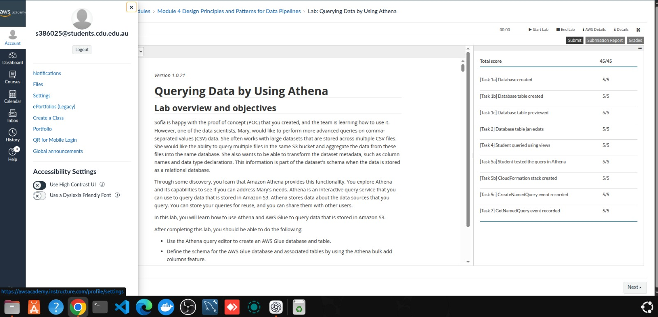

Individual project contribution
Kavya’s documented contribution area is data acquisition and repository setup (POT-01–02). This component covers organising the two-class PlantVillage dataset, recording source provenance and preparing a traceable data inventory. The project outputs include 2,000 images, balanced class counts and documented source revisions, which provide the foundation for reproducible preprocessing and model development.
Supporting evidence
Data provenance | Class inventory
Professional reflection
The principal lesson from this component is that dataset traceability is part of model quality. Recording source revisions, labels and storage locations makes later results easier to audit. Future work should maintain a clear connection between each dataset change and its supporting repository record.
Section 4: Individual Work and Contribution (continued)
4.2 Sayed Mahidul Islam Rafel | S387949
Danala Group 7 | Image preprocessing and exploratory analysis
Laboratory 1 evidence
Lab: Querying Data by Using Athena (Module 4). Recorded score: 45/45 (100.00%). The session ended on 2 September 2026 at 23:39:14 (UTC−07:00). The screenshots identify S387949; they show a graded attempt rather than full marks. The end time is session evidence, not a separate grading timestamp.
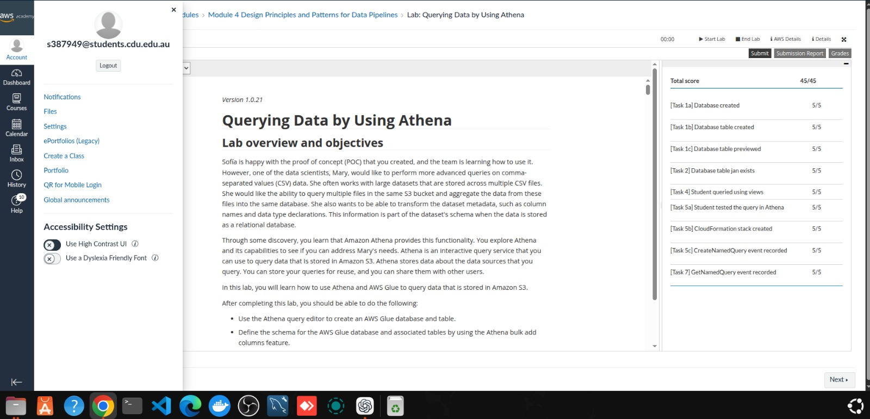
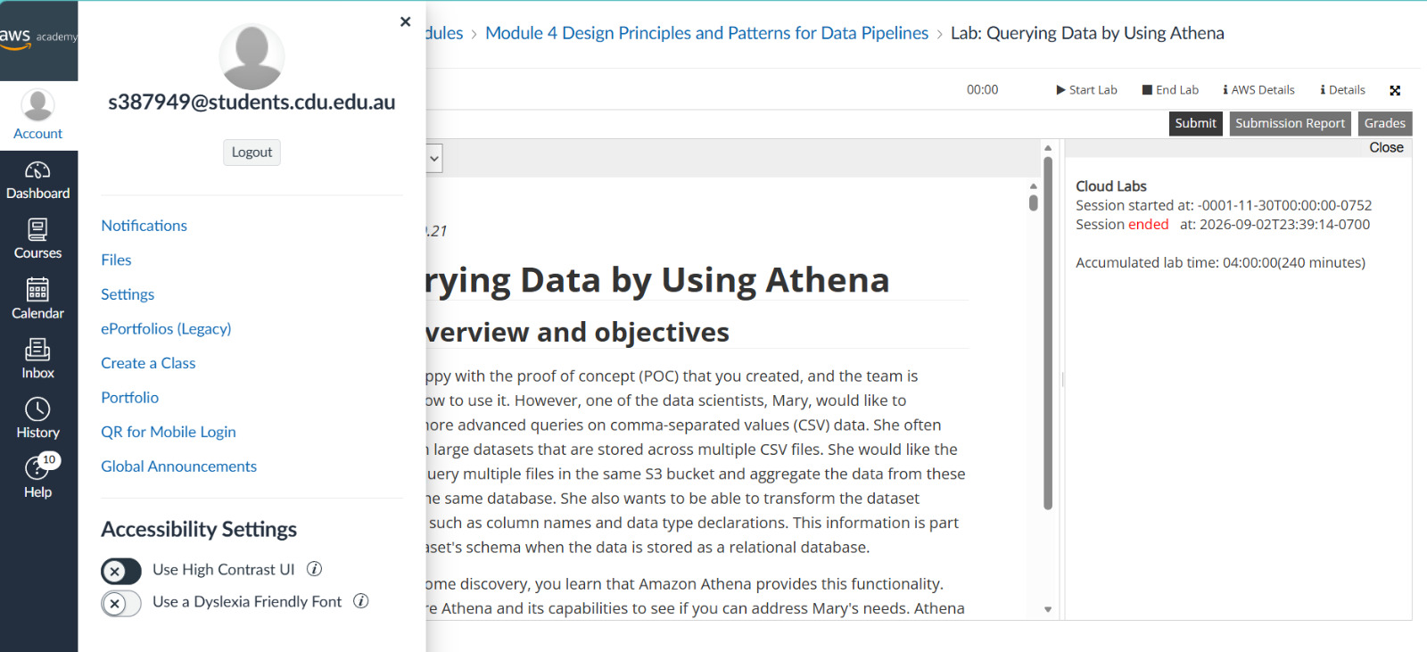
Individual project contribution
Sayed’s documented contribution area covers preprocessing and exploration (POT-03–05): leaf-group construction, split design and training-only augmentation. The resulting evidence records 350/75/75 leaf groups across training, validation and testing, with no shared groups. These controls reduce leakage between related images.
Supporting evidence
Group-overlap audit | Split summary
Professional reflection
The key lesson is that related images must stay in the same partition. Data preparation affects the credibility of evaluation, not just image format. The 45/45 lab result also identifies scope to revisit uncredited tasks and verify the final assessment evidence.
Section 4: Individual Work and Contribution (continued)
4.3 Mahdi Hasan Abdullah | S394885
Danala Group 7 | Model development and training
Laboratory 1 evidence
Lab: Querying Data by Using Athena (Module 4). The screenshot identifies S394885 and records the session ending on 29 August 2026 at 13:31:17 (UTC−07:00), with 131 minutes of accumulated lab time. Recorded score: 45/45 (100.00%).
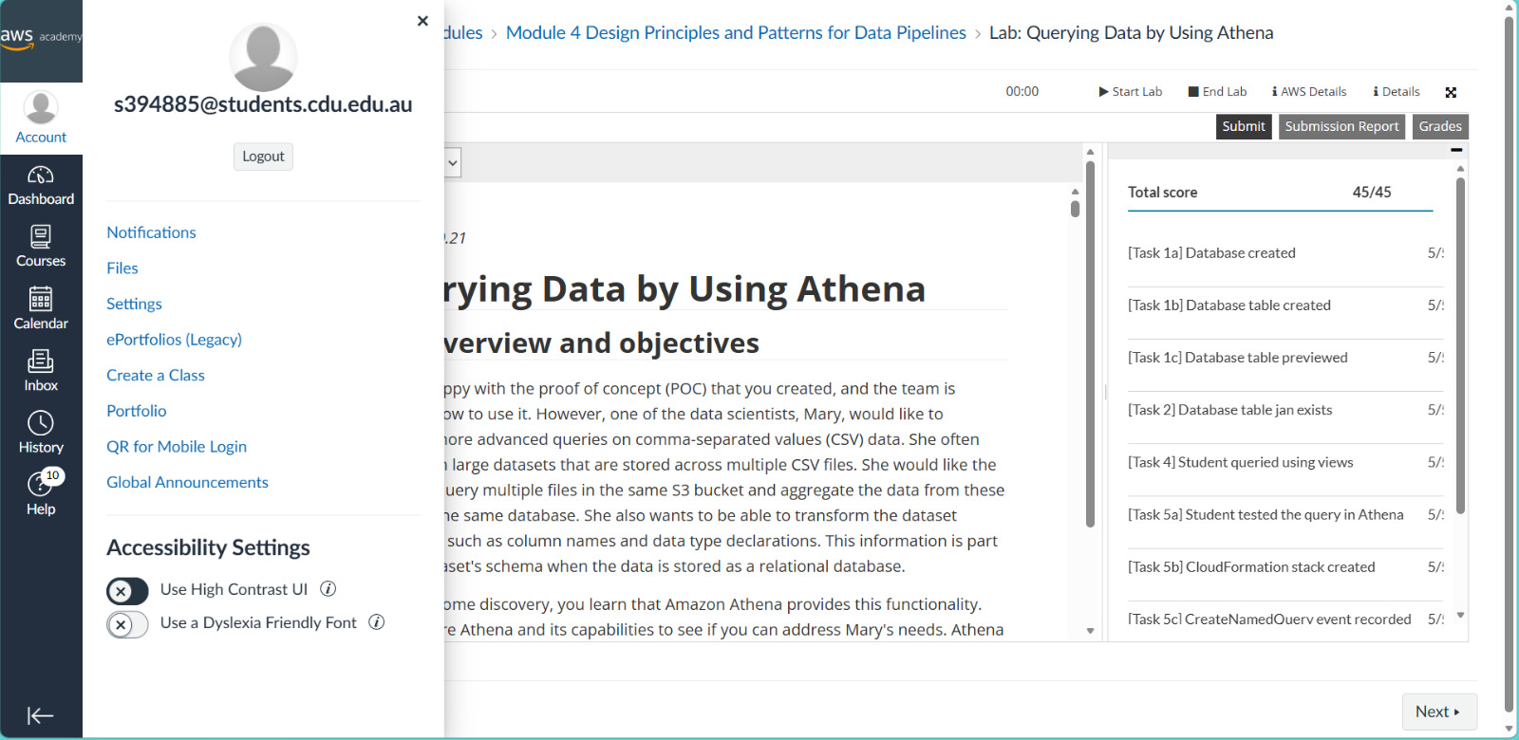

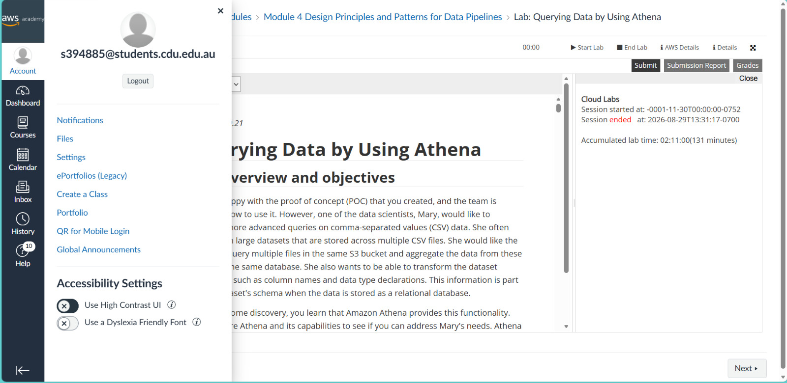
Individual project contribution
Mahdi’s documented contribution area is model development and training (POT-06–08), covering the logistic baseline, custom PotatoCNN and MobileNetV2 comparison. The recorded implementation includes early stopping, saved model weights and validation-selected thresholds. The custom CNN has 93,377 parameters, while MobileNetV2 provides the strongest internal accuracy at 99.67%.
Supporting evidence
CNN configuration | Model comparison | Training history
Professional reflection
The model comparison shows why a high internal score needs an external check. MobileNetV2’s accuracy falls to 58.56% on PlantDoc, so further progress depends on representative data as well as architecture choice. Checkpoint selection and threshold decisions should remain separate from final testing.
Section 4: Individual Work and Contribution (continued)
4.4 Partha Mallik | S392819
Danala Group 7 | Evaluation, visualisation and error analysis
Laboratory 1 evidence
Lab: Querying Data by Using Athena (Module 4). Recorded score: 45/45 (100%). The session ended on 3 September 2026 at 12:36:03 (UTC−07:00). Both screenshots identify S392819. The full score supports completion of the graded tasks; the displayed timestamp records the session end.
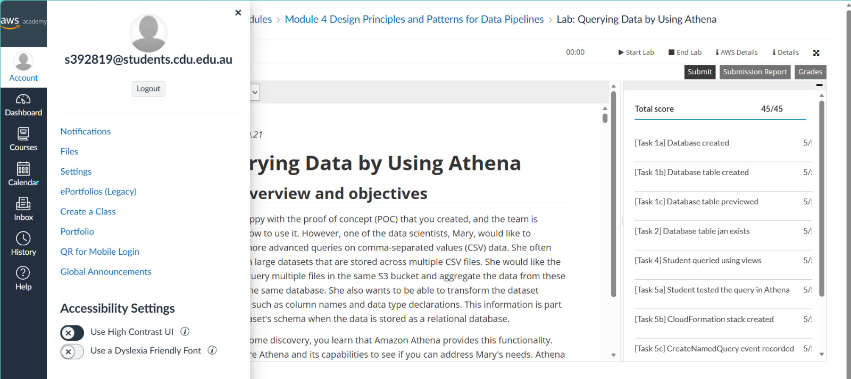
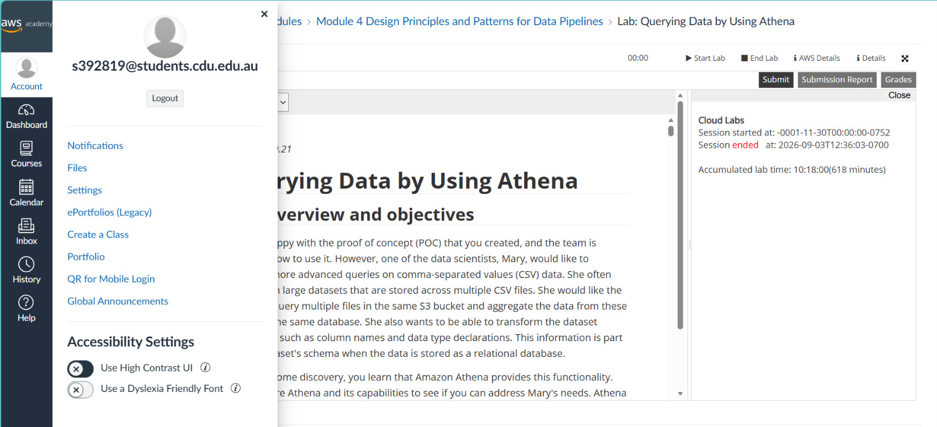
Individual project contribution
Partha’s documented area covers evaluation, visualisation and error analysis (POT-09–14). Public commits under Partha115 record uploads of assessment reports and the architecture, results and planning package. These provide direct evidence of repository integration alongside the project’s internal/external evaluation outputs.
Supporting evidence
Visualization & Error Analysis| Report upload: 22d1031 | Evidence upload: d328570
Professional reflection
Evaluation must make limitations visible as well as report accuracy. The 14 custom-CNN errors and the PlantDoc performance gap demonstrate the importance of class-specific analysis and traceable result records. Future reviews should connect each conclusion to its prediction table and documented decision.
Section 4: Individual Work and Contribution (continued)
4.5 Datta Sai Kanaparthi | S385673
Danala Group 7 | Documentation, ethics review and final integration
Laboratory 1 evidence
Lab: Querying Data by Using Athena (Module 4). Recorded score: 45/45 (100.00%).

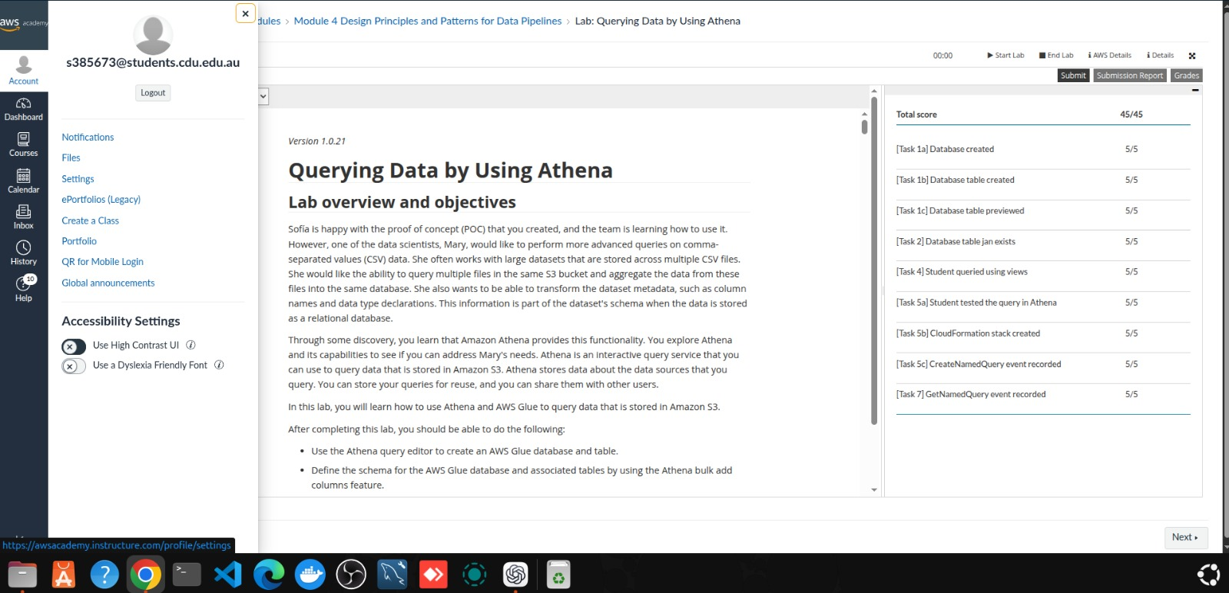

Individual project contribution
Datta’s documented contribution area is documentation, ethics review and final integration (POT-15–16). This area brings the project objectives, architecture, experimental results, risk analysis and governance records into a coherent report. Its central requirement is to keep the claims consistent with the evidence, including the two-class scope and the limitations of external performance.
Supporting evidence
Scope-change record | Risk register | Assessment records
Professional reflection
Clear documentation helps readers distinguish implemented work from proposed extensions. The external results and unresolved evidence gaps show why a report should be explicit about limitations and version history. Future integration should reconcile every figure, table and claim with the final recorded experiment.

